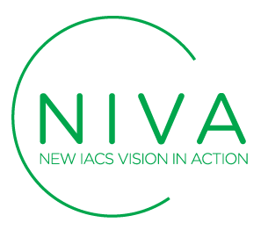

NIVA – NEW IACS VISION IN ACTION
Annex I: Consortium Declaration
14 January 2022

Title of the proposal: ________________________________________________________

On behalf of _____________________________(Third party name) established in ______________________________, (Official address), VAT/TAX number_________________, represented for the purposes of signing and submitting the Declaration by ___________________________ (Name of legal representative), declares that all provided information below is true and legally binding.
The Consortium leader declares that all Consortium partners have agreed on their roles and budget shares.

The Consortium leader is solely responsible to distribute the budget shares to Consortium partners in accordance to this Consortium Declaration.

NIVA project bears no responsibility in case the Consortium leader violates the mutual agreement set in this Consortium Declaration.

NIVA project bears no responsibility in case of dispute among Consortium partners regarding IP rights and allocation of income generated through reward crowdfunding campaigns.

By submitting this document, Consortium accepts all the rules explained in NIVA Open Call Guide for Applicants.

Consortium leader
Third party
Full address
Legal representative
Sector
Are you a Paying Agency or Managing Authority for Common Agricultural Policy regulations? | Yes No
Are you a technology provider for solutions for monitoring Common Agricultural Policy regulations? | Yes No
Are you another type of organisation? Which?
Legal representative signature and stamp

Project partner 2
Third party name
Full address
Legal representative
Sector
Are you a Paying Agency or Managing Authority for Common Agricultural Policy regulations? | Yes No
Are you a technology provider for solutions for monitoring Common Agricultural Policy regulations? | Yes No
Are you another type of organisation? Which?
Legal representative signature and stamp

Project partner 3
Third party name
Full address
Legal representative
Sector
Are you a Paying Agency or Managing Authority for Common Agricultural Policy regulations? | Yes No
Are you a technology provider for solutions for monitoring Common Agricultural Policy regulations? | Yes No
Are you another type of organisation? Which?
Legal representative signature and stamp

