**PART Β΄**

**TECHNICAL SPECIFICATIONS**

1. Overview

Central to many processes in monitoring for CAP Payments are the recognition of agricultural land use, activities, and reference parcel boundaries. This process of recognition has been more and more automated over the past decades through the use of digital technologies such as remote sensing through satellite or aerial images, data infrastructures, Geographical Information Systems, but also through geospatial intelligence methods, meant as the ability to learn or investigate new or trying situations. These automated recognition processes have offered advantages to farmers and Paying Agencies lowering the administrative burden, however Artificial Intelligence techniques, such as machine learning & deep learning, would allow to further improve this automated recognition process as recently seen new applications in agriculture and food systems. In terms of the use of Artificial Intelligence for automated recognition, some initial use of standard algorithms, such as Random Forest, has been made for crop classification and object recognition on raster images, but there is a lot more potential for the application of new AI methods-algorithms for automated recognition of object boundaries & agricultural activities, especially through the application of advanced AI processors in combination with geospatial intelligence methods-algorithms.

Within the context of NIVA, innovation is built by combining state-of-the-art technology and developing open source components that are piloted in large scale Use-Cases (UC) across EU Member State’s Paying agencies. Machine Learning is used for classification of crops on agricultural parcels, the identification of management practices and detection of objects on, or bordering, the agricultural parcels, such as trees, roads, buildings, etc. using Earth Observation, next to text mining applications to complete applications of farmers based on previous information or hand-written texts. Now that basic operations are functioning within the UC systems, there is need for more advanced AI expertise and algorithms to improve the quality of the detection/ recognition on satellite data, in other words, to detect more, or recognize better, elements in the same datasets by using more advanced techniques. In practical terms, addressing the challenges of classifying small sized agricultural parcels, fallow land, Mediterranean pastures and detecting smaller or lower objects affecting the reference parcel boundaries need to be tackled.

1. Project framework / Requirements

Paying Agencies from 9 EU Member States join forces to realize a new vision on the Integrated Administration and Control System (IACS) – the instrument for CAP governance – in a project called: “New IACS Vision in Action” (NIVA). NIVA project demonstrates a clear intention to collaborate in exploring innovations and working together in creating an innovation ecosystem. NIVA project aims to modernize IACS by making efficient use of digital solutions and e-tools, by creating reliable methodologies and harmonized data sets for monitoring agricultural performance while reducing administrative burden for farmers, paying agencies and other stakeholders.

NIVA consists of 7 WPs (Work Packages). WP2 consists of 9 UCs (Use Cases) / 9 Pilots.

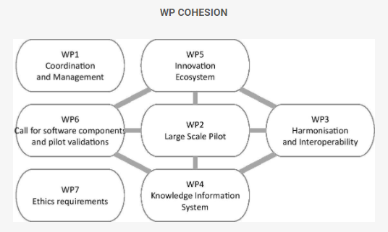

Figure 1. NIVA Work Packages

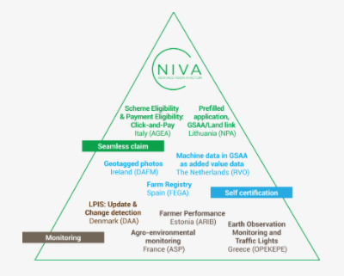

Figure 2. NIVA UCs diagram

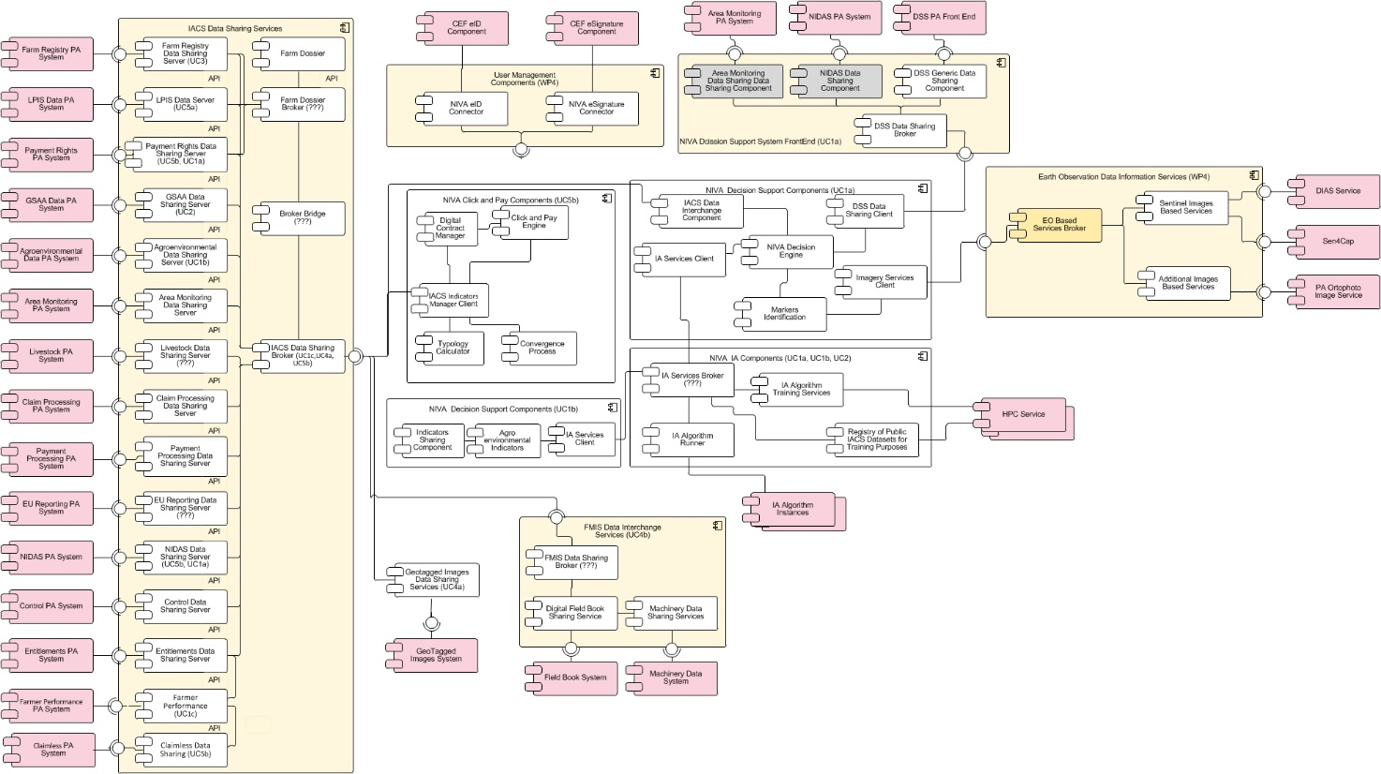

Figure 3. NIVA UML component diagram

**UC1a** shall produce a Decision Support System (NIVA – DSS) to conclude in traffic light codes in parcel level, which will also include a tool and a process to deal with yellow cases.

In more detail, UC1a’s Decision Support System:

a. will be open and capable to receive and plug-in other EO Classification Engines (registered external EO systems) aiming to enhance the assessment procedure of parcel declarations. This re-usability characteristics of the NIVA-DSS will also contribute significantly to the sustainability of the developed tool beyond the project end date.

b. will provide a Business Rule Management System in order to build eligibility criteria to be checked (decided by each Paying Agency)

c. will incorporate outcomes from third parties (registered apps – e.g. smartphone based Geotagged Photos, registered FMIS’s) in order to handle parcels assigned with yellow traffic light.

d. will incorporate data fusion techniques aiming to enhance the capability of such systems to receive large volume of different datasets and from diverse sources of information, improving the reliability and accuracy of the generated traffic lights with minimum human intervention.

**UC5a** aims to minimize manual procedures related to the LPIS administration, and the CAP application. The method to reach the goal, is by providing algorithms to update LPIS automatically. More precisely to set up change detection processes using machine and/or deep learning based on orthophotos and other relevant data. By using machine and/or deep learning to update LPIS, the use case aims to be the first of its kind, to deliver algorithms in a quality that can be used for automatic updates of LPIS.

1. Use Case 1a framework / requirements: EO monitoring and Traffic lights.

The NIVA Use Case “UC1a - EO monitoring and Traffic lights’ shall demonstrate how “monitoring” can be implemented and deployed at a parcel level using new methods-algorithms, hence recognition of the land use (e.g. crop) and management actions of the farmers is crucial for such case. The main available EO Classification engine deployed in UC1a is SEN4CAP, which uses a Random Forest method for crop type classification of agricultural management and is mainly tuned for Northern European countries.

However, there are certain needs that have to be addressed. These needs are:

1. Explore advanced Artificial Intelligence methods-algorithms based on neural networks/ gradient learning and similar. Testing new AI classification methods-algorithms is needed to achieve higher accuracy in crop classification and to exploit additional data such as indices other than those provided by SEN4CAP. Additionally, moisture and water related indices are needed in order to assist the crop classification and crop distinction of specific crop types i.e. rice.

We also need to investigate if other available data such as information from field visits (field visits will be provided by OPEKEPE) along with farmer’s declarations can be used as training data in order to strengthen the discriminating power of classifiers. The field visits should be representative and satisfactory sample of all the requested to be classified crop types and land covers, especially the ‘difficult’ types of them such as Mediterranean permanent grasslands and fallow land.

1. Use images other than high-resolution satellite data: SEN4CAP includes algorithms/classifiers for Sentinel 1 and 2 and LANDSAT 8 images. What is also needed are algorithms/classifiers also for other higher resolution satellite images (high-high resolution between 4 and 1,5 meters), in order to deal with small sized parcels or elongated and narrow shaped parcels.
2. Fallow land and Mediterranean pasture detection (see below the Regulation about pastures): As for fallow land, the SEN4CAP project has developed a processor to detect tillage activities as another supplementary marker, included in the “Agricultural practices monitoring L4C” processor. The SEN4CAP tillage detector focuses on tillage after harvest of the crop and cannot be executed in a generic way. As for pasture detection, SEN4CAP does classification only for grassland mowing detection. What is needed is a classifier/algorithm which detects the more specific Mediterranean-type pastures. This concerns the detection of declared pasture areas (vegetation types that consist of pastures according to Corine 2018), the recognition of eligible and non-eligible areas of declared pastures and application of a pro-rata system.
3. Use Case 5a framework / requirements: “LPIS update & Change detection”

5a “LPIS update & Change detection” facilitates LPIS update by locating changes of non-agricultural elements (appeared or disappeared). The aim is to minimize manual procedure with a new change detection process using automated images analysis. The proposed method is to develop algorithms to detect elements relevant for updating the LPIS. France[1] and Denmark[2] are already developing methods to detect specific elements. This use case will not be able, in the current framework, to have a complete set of elements for the LPIS update, and neither explore the opportunities for using satellite imagery in updating the LPIS.

Therefore, the requirements for the call for subcontracting Use Case 5a are:

* Developing algorithms (deep learning or other suitable machine learning methods), which can complement the algorithms being developed in France and Denmark using very high resolution (30 – 50 cm resolution) imagery. The development shall be done in interaction with the iterative development already taking place in Use Case 5a.
* Explore the possibilities for using satellite imagery for updating LPIS. Develop algorithms (machine- and/or deep learning) for updating LPIS.

The elements could e.g. be established or removed paved roads, kitchen gardens, permanent storage, recreational areas, abandoned parcels (with scrub lands and nature regrowth), etc., and e.g. suggestions for reference parcel boundaries. The number of algorithms / elements for LPIS needed from this call are five.

Depending on quality, data from the developed algorithms can be used as:

* Precise geo-located change detection alerts
* Precise suggestions for changes (e.g. parcel/ element suggestion guiding system)
* Automated cut out. An update of the reference parcel automatically be created.

1. Description of the Subcontracting

**Objectives: 1. This project involves the development of machine-learning classification algorithms aiming to extract crop type information using dense time series of satellite imagery**

1.1. Smart AI for Agro-management /Development of spatially explicit advanced AI-based algorithms using high resolution EO-data (Sentinel).

* Markers & crop classifiers based on different classification methods-algorithms than Random Forest e.g. more advanced deep learning, machine learning algorithms.

Create/offer an advanced crop classifier in order to provide better crop classification results compared to Sen4CAP in terms of accuracy[3]. In addition, production of more biophysical indicators such as NDWI and moisture index must be included to the crop classification component (i.e. to assist detection of rice fields).

Create/offer a fallow land classifier component to detect fallow land areas and discriminate them between i.e. abandoned areas, natural bare areas, pastures, cultivated arable areas. A tillage/plowing marker is also essential that will satisfy the requirement/precondition of one plowing/tillage per year.

* Workbench evaluation of different machine learning/deep learning processors (other than Random Forest).

The bidder is expected to propose one alternative classification component per need based on AI and produce a validation report that will show the results of different algorithms[4].

1.2. High-resolution Agro-management detection supported by high-high resolution satellite images

* Methodologies to deal with small or elongated and narrow shaped parcels[5] and Mediterranean pastures.

Create/offer advanced algorithm to deal with small or elongated and narrow shaped parcels by using multitemporal and multi-sensor dataset of high-resolution satellite images (Sentinel 1&2) and high-high resolution satellite images (4-1,5 m). To cope with high spectral variability of crops on one-hand and small sized parcels on the other hand, the synergy of high-resolution satellite images (Sentinel 1&2) and high-high resolution images (i.e. Planet, Spot) is to be investigated. The necessary high-high resolution satellite images will be provided by the Contracting Authority at its discretion (see part A) while any other additional high-high resolution satellite images required will be provided by the contractor. While multi-temporal data of Sentinel 1,2 offers high potential for capturing crop phenology, the spatial resolution of the imagery is inadequate to capture the small-sized parcels of the Mediterranean landscape. In Sen4CAP platform for instance, there is a constrain of 3 pixels per parcel and with at least 1 pixel whose centroid falls inside 5 m or 10 m buffer (respectively for S2 and S1). Changes in phenological states of crop types with similar crop calendar can only be monitored with the high revisit capacity of Sentinels.

Create/offer advanced algorithm dedicated to the detection of Mediterranean pastures, by paying special attention to excluding natural non-eligible areas (forest and woodland areas) > 100 m2 and artificial man-made features of any size by using both high-resolution satellite images (Sentinel 1&2) and high-high resolution satellite Images (i.e. Planet, Spot).

The proposed classification method for the case of Mediterranean pastures must focus not on the discrimination between the permanent grassland and the perennial grasses and other herbaceous forage being part of the arable land that occur to the North European countries but mainly on the discrimination between permanent grassland (eligible areas) and forest, woodland and rocky areas with intense relief and high altitude (non-eligible areas) as occur mainly to the South European countries. The tenderer should investigate / propose the optimal methodology to achieve assessing and detecting Mediterranean pastures. The tenderer should take into account the categorization of pastures according to Corine 2018 which involves the following eligible vegetation types:

a. Meadows - pastures (Corine Land Cover 2018 class 2.3.1)

b. Natural grassland (Corine Land Cover 2018 class 3.2.1)

c. Moors and Heathland (Corine Land Cover 2018 class 3.2.2)

d. Sclerophyllous vegetation (Corine Land Cover 2018 class 3.2.3)

The following non-eligible features are to be excluded:

     a. Artificial features of any size

    b. Natural features > 100m2 (water surfaces, rocky surfaces, non natural/agricultural vegetation, shrubs, trees and bushes that a man can't walk through)



Figure 4. Example of a Mediterranean pasture

**Objectives: 2. Development of a change detection engine, which automatically detects elements useful for LPIS update using satellite imagery of high-high and very high resolution satellite images and machine learning algorithms, so as to minimize human intervention.**

* **Using orthophotos for further types of elements for the updating of LPIS.**
* **Using satellite imagery for updating LPIS**

2.1. Concerning very high resolution orthophotos change detection (<50cm)/ Identification of agro-management and objects impacting LPIS (incl. Reference Parcels) updates for CAP monitoring

o Use of very high resolution orthorectified images to detect changes.

o Workbench evaluation of different machine learning/deep learning algorithms (other than Random Forest)

Recognize objects affecting the reference parcels outer boundaries and within the reference parcels. Thereby detecting changes using advanced machine learning techniques using very high-resolution orthophotos and create a delineation of those changes in an automated updating workflow of the LPIS. The number of algorithms / elements for LPIS needed are five (5).

The development in Use case 5a that have already being done, have focused on these algorithms/ elements:

* Buildings
* High vegetation
* Trees in line
* Trees in groups
* Ponds (incl. vegetation at the brink)
* Artificial covered surfaces
* Unpaved roads

The objectives of the subcontracting are therefore, to add five additionally algorithms/ elements for updating LPIS. The types of elements could, for example, be non-eligible hedges/wooded vegetation, recreational areas, gardens, watery areas that are not ponds, non-eligible grass areas etc.

The tenderer should investigate/ propose the optimal methodology in order to meet the requirement.

2.2. Concerning high and high-high resolution orthophotos (EO) change detection

o Methods for hotspot of change detection based on EO data (flagging areas with high confidence of change detected).

o Methods for change detection in parcel boundaries and within the parcels using a) Sentinel 1 & 2 and b) high-high Resolution Satellites (e.g. Planet, Spot)

The development is aiming to investigate the possibility of using satellite imagery for updating LPIS. Therefore, the main objective is to investigate the opportunities for satellite-based LPIS update – would it be possible to use satellite imagery for updating LPIS.

The investigation shall be grounded in both high and high-high resolution imagery.

1. Description of the Proposed Components

|  |  |
| --- | --- |
| **Components** | **Need addressed by Components** |
| 1.1 Basic Crop Classifier Component | Markers and crop classifier/ algorithm based on different classification method-algorithm than Random Forest e.g. machine learning, deep learning algorithms and moisture and water indices, to deal with crop classification better than SEN4CAP.  Processing of high-resolution satellite data (Sentinel). |
| 1.2 Small Parcel classifier Component | Crop classifier based on different classification method-algorithm than Random Forest, e.g. machine learning, deep learning algorithms, to deal with small parcel sizes or elongated and narrow shaped.  Processing of high- high-resolution satellite data (4m to 1,5 m). |
| 1.3 Fallow land classifier Component | Crop classifier based on different classification method-algorithm than Random Forest e.g. machine learning, deep learning algorithms.  A marker that will check the requirement of one ploughing/tillage per year.  Processing of high-resolution satellite data (Sentinel). |
| 1.4 Mediterranean pasture classifier Component | Classifier/algorithm based on different classification method-algorithm than Random Forest e.g. machine learning, deep learning algorithms.  Classifier/algorithm which detects more specifically Mediterranean type pastures so that it excludes non-eligible natural areas> 100m2 (at least) i.e. forest, woodland, rocks and artificial man made areas of any size and applies pro-rata system (pro-rata eligibility factor)  Processing of high and of high-high resolution Satellite data |
| 1.5 Change detection identifier Component (for very high, high-high and high resolution orthoimages) | Use of very high resolution orthophotos to detect changes  Workbench evaluation of five different machine learning/deep learning algorithms (other than Random Forest)  Methods for hotspot of change detection based on high resolution EO data (Sentinel 1 & 2, Landsat etc)  Detecting changes in parcel boundaries using high resolution EO data (Sentinel 1 & 2, Landsat etc)  Detecting changes in parcel boundaries using high-high resolution satellites (4m-1m) |

The components must be self-contained, independently deployable and must communicate with other components over well-defined APIs. Through well specified API calls, the calculated outputs must be retrievable, based on the standard semantics defined by the NIVA consortium. Similarly expected inputs should be received through well defined APIs following the semantics defined by the NIVA consortium. The current semantic model is described in<https://www.niva4cap.eu/uploads/downloads/D3.2%20Common%20Semantic%20Model_v3.pdf>.The definition of any API that will be requested to adhere to will be provided to the subcontractor. Data-sharing interoperability mechanisms imposed by the NIVA project, such as the open EO API should also be respected. These are also defined in the WP3 and will be provided to the subcontractor. Work Package 3 (WP3) and its deliverables such as D3.1 – D3.5 provide guidelines on a number of issues related to interoperability, semantic models and software development in the NIVA consortium. These guidelines can be found at the NIVA site (<https://www.niva4cap.eu/deliverables>); the software delivered should be according to the guidelines provided there. Finally, care must be taken so that the provided solutions are compatible with any orchestrator components developed as part of the WP6 of the NIVA projects.

Given that there is a range of classification techniques that can be used the implemented components should use methods-algorithms based on advanced AI techniques beyond the standard Random Forest approach already available through Sen4CAP (<http://esa-sen4cap.org/>). Components may include either totally alternate algorithms such as Convolutional Neural Networks or decision-tree-based classification schemes such as Gradient Boosting Trees.

The source code and the algorithms of all components of the subcontracting must be accompanied by automated installation and configuration procedures. Build scripts, Deployment scripts and automated tests (unit tests, integration tests, system tests) are considered to be part of the source code. Ideally the proposed solution will also be able to be deployed as a dockerised container, and appropriate docker files should be provided. The source code with its whole history must be published openly at a publicly available repository (e.g. GitHub, GitLab etc.) with a EU-PL license. In any case clear building installation and deployment instructions must be provided.

Direct dependencies should be restricted on software distributed with compatible licenses. EU-PL has a list of licenses that are compatible with it. In case this is not possible because there is not an equivalent open source software that can be used, care must be taken so that the proprietary software will be at least free for non-commercial use. In case this is again not possible approval for its use must be sought by the NIVA consortium.

1. Use Cases component Diagram

The new components that will be developed by the current proposal will act as independentand will provide the systems of the 2 Use Cases with information in order to make the right decisions concerning traffic light at parcel level for UC1a and change detection and detection of boundaries in UC5a. Each component is incorporated/inserted into the orchestrator component. Figure 4 shows how the new components will fit into the overall NIVA architecture. Blue components indicate components that are either developed, or under development by the NIVA consortium. Transparent (white) components are the components being requested for development. The diagram shows the interfaces that will need to be implemented by the subcontractor in order to connect to the NIVA architecture:

* Classification interface to be able to feed the NIVA Decision Engine (UC1a) with classification results.
* ImageRetrieval interface to get satellite images from the NIVA Imagery Services Client
* LPIS Data Service to connect and provide data to UC5a.
* DataSetRetrieval for publishing/importing data sets used for training purposes

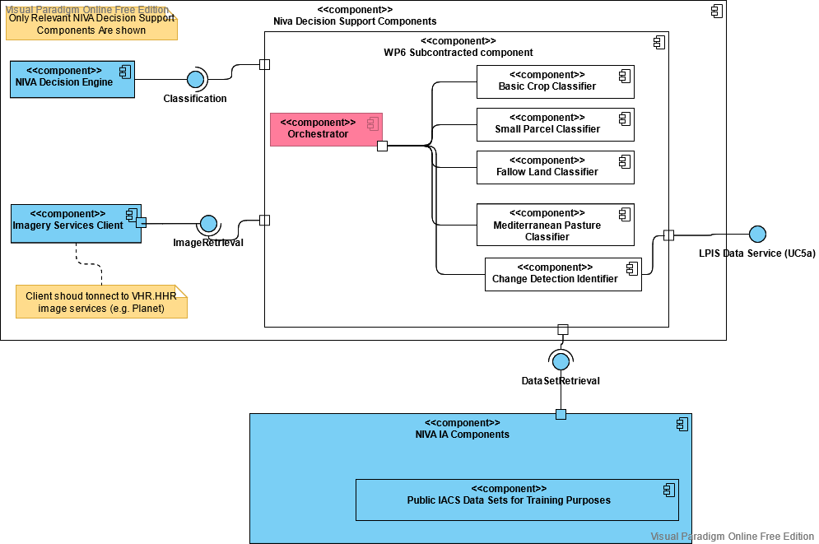

Figure 5. A component diagram of the architecture

1. Acceptance scenarios for the components

**Component 1.1:** Comparative assessment and validated results compared to SEN4CAP for several crops (arable and permanent crop types). Estimating accuracy statistics as described in section “QUALITY ASSURANCE DURING IMPLEMENTATION” and passing the validation test.

**Component 1.2:** Crop type classification for regions with relatively small or elongated and narrow shaped parcels employing high-high (<4m) resolutions data. Small parcel or elongated and narrow shaped parcels sizes characteristics: S2pixMIN = 3, after buffer of 5m and S1pixMIN = 1, after buffer of 10m. The methodology should enable the assessment of at least 90% of non-assessed by SEN4CAP parcels. Estimating accuracy statistics as described in section “QUALITY ASSURANCE DURING IMPLEMENTATION” and passing the validation test.

**Component 1.3:** Classification of fallow land and definition of markers. As far as we refer to the good agricultural condition of fallow land, we accept as precondition one ploughing/tillage per year.

Estimating accuracy statistics as described in section “QUALITY ASSURANCE DURING IMPLEMENTATION” and passing the validation test.

**Component 1.4:** The methodology for the classification of Mediterranean pasture detects eligible and non-eligible areas of declared pastures, applies a pro-rata system. Estimating accuracy statistics as described in section “QUALITY ASSURANCE DURING IMPLEMENTATION” and passing the validation test.

**Component 1.5:**

1. Change detection using very high-resolution images.

2. Comparative assessment and validation results of change detection using very high-resolution imagery with five different classifiers including neural networks, nomenclatures, and stratification strategies. Estimating accuracy statistics as described in section “QUALITY ASSURANCE DURING IMPLEMENTATION” and passing the validation test.

3. Detecting and delineating changes in reference parcel boundaries using high resolution EO data (Sentinel 1 & 2, Landsat etc.)

4. Detecting and if possible delineating changes in reference parcel boundaries using high-high resolution satellites (< 4m)

5. Comparative assessment and validation results with different classifiers including neural networks, nomenclatures, and stratification strategies (also compared to SEN4CAP).

1. Open Source

The source code and the algorithms of all components of the subcontracting must be accompanied by automated installation and configuration procedures and must be published openly at a publicly available repository (e.g. GitHub) with an EU-PL license. Core dependencies on proprietary components are not acceptable (as has been mentioned above).

1. Data to be provided for subcontracting implementation.

Specific digital geospatial data will be made available by the Contracting Authority for the implementation of the project involving specific test sites (according to developing components).

In more detail:

1. **Subsidy applications:** the necessary for the project digital files of the farmer’s declarations including a vector layer with the declared crop type for each agricultural parcel (of the respective year of inspection) of the corresponding specific test sites. (Greece)
2. **Crop type list:** a detailed crop type list of the declared crop types and a crop type list grouped according to the phenology of crops to be used during crop classification. (Greece)
3. **Crop type data acquired from field visits of the respective year of inspection** of the corresponding specific test sites. (Greece)
4. **Orthophotos:** the most recent orthophotos maps of very high resolution used in current LPIS. (Denmark)
5. **Ηigh-high resolution satellite images:** the necessary high-high resolution satellite images will be provided by the Contracting Authority at its discretion (see part A) while any other additional high-high resolution satellite images required will be provided by the contractor. (Greece & Denmark)
6. **Digital Terrain Model (DTM):** aDigital Terrain Model (DTM) will be provided, if needed, for the corresponding specific test sites.
7. **Current LPIS Data (reference parcels ilots and subilots):** the necessary for the project digital files of the existing LPIS of the IACS concerning specific test sites (Denmark). The files are geospatial data of .shp, .gdb format in specific Geodetic System.
8. Technical requirements – Conformity Tables

Candidate contractor should clearly state where the technical offer covers each project requirement.

|  |  |
| --- | --- |
| 1. **General Specifications** | |
| **Description of the procurement requirements** | **Reference paragraph of Tender’s response** |
| * 1. The tenderer shall describe in the proposal how the following requirements will be met over the duration of the contract:   + Using EO satellite of various providers (Sentinel and high-high resolution imagery), requirement currently not met by Sen4cap (which only uses Sentinel and Landsat)   + Using additional raster or vector files (such as vegetation indices, elevation info, data from field visits, Copernicus Corine Land Cover classes etc. specially for the Mediterranean pastures)   + Estimating different Radiometric indices i.e. moisture and water index   + Implementation of advanced AI algorithm for performing automated crop type mapping and benchmarking SEN4CAP for effectiveness of common classification techniques (RF)   + Perform detailed validation analysis of the results by using different classifiers and different radiometric indices (type error α and β)   + Extract confidence level or prediction probability per pixel/per parcel   + Analysis and definition of a classification scheme to deal with small parcel sizes or elongated and narrow shaped parcel by processing Sentinel imagery and high-high resolution satellite data   + Analysis and definition of a fallow land detection method-algorithm taking into account ploughing markers /growing vegetation indicators.   + Analysis and definition of a classification scheme which meets the needs of the Mediterranean pastures |  |
| * 1. The tenderer shall describe in the proposal how the following requirements will be met over the duration of the contract: * Propose an operational and automated method-algorithm for detection of possible changes (with more advanced AI techniques by using high, high-high and very high resolution orthophotos. * Delineate ‘meaningful’ changes such as urban or natural changes and update LPIS reference parcels boundaries using high, high-high and very high resolution orthophotos. * Testing and comparative analysis of the results |  |
| * 1. The tender shall describe in the proposal the technologies that will be used e.g. database, OS, applications servers, frameworks, programming languages, containerization technology, as well as the development methodology.   A description of the team undertaking the task, its structure and lead roles with emphasis on the experience and abilities of persons taking up lead roles, especially that of the project management, is also expected. |  |
| The tenderer accepts in full and without restriction the following:   1. The definition of “permanent grassland and permanent pasture” according to Regulation (EU) No 1307/2013 and its amendment (EU) Regulation No 2393/2017 (Omnibus), Article 3 is land used to grow grasses or other herbaceous forage naturally (self-seeded) or through cultivation (sown) and that has not been included in the crop rotation of the holding for five years or more, as well as, where Member States so decide, that has not been ploughed up for five years or more; it may include other species such as shrubs and/or trees which can be grazed and, where Member States so decide, other species such as shrubs and/or trees which produce animal feed, provided that the grasses and other herbaceous forage remain predominant. Member States may also decide to consider as permanent grassland: land which can be grazed and which forms part of established local practices where grasses and other herbaceous forage are traditionally not predominant in grazing areas; and/or land which can be grazed where grasses and other herbaceous forage are not predominant or are absent in grazing areas.   Supplementary criteria may be defined that ensure breeding livestock activity such as:      a. Road network (primary, secondary, agricultural roads, paths)      b. Stables      c. Farmer's accommodation facilities      d. Watering points – facilities      e. Feces in large amounts (usually close to stables)  A pro-rata eligibility factor is applied, after ineligible elements have been removed, according to the following table:   |  |  |  | | --- | --- | --- | | **class** | **CAPI estimated eligibility factor** | **Final eligibility factor** | | **1** | 0% up to 25% | 0% | | **2** | 25% up to 50% | 37,5% | | **3** | 50% up to 70% | 60% | | **4** | 70% up to 90% | 80% | | **5** | 90% up to 100% | 100% |  1. Eligibility Criteria coded as algorithms for Basic Payment Scheme (see “LPIS guidance document DSCG/2014/33”), for Crop Specific payment for Cotton (see “REGULATION (EU) No 1307/2013 OF THE ΕUROPEAN PARLIAMENT AND OF THE COUNCIL of 17 December 2013”, TITLE IV, Chapt. 1, Art. 56-60) and for certain Voluntary Coupled Schemes (see “REGULATION (EU) No 1307/2013 OF THE ΕUROPEAN PARLIAMENT AND OF THE COUNCIL of 17 December 2013”, TITLE IV, Chapt. 1, Art.52-53) 2. As a Member State we have legislate (Ministerial Decision 1337/ 2-7-15) for the arable land, as far as we refer to the good agricultural condition, we accept one plowing per year. So, the dedicated detection marker should satisfy this requirement. We should also take into consideration that an agricultural parcel below a minimum size (below or equal to 0.03ha / 0.05 ha) may not be accounted for in the frame of BPS/SAPS calculation. | **(YES/NO)** |
|  |  |
| 1. **QUALITY ASSURANCE DURING IMPLEMENTATION** | |
| **Description of the procurement requirements** | **Reference paragraph of Tender’s response** |
| Concerning the quality of the deliverables described the following will be considered:  The reliability of the components will be based on the statistical widespread concepts of the type 1 (α) and type 2 (β) errors as proposed by the Commission (DS/CDP/2018/18):  1. type 1 error [α] is the rejection of a true null hypothesis (a "false positive" or false RED finding),  2. type 2 error [β] is the failure to reject a false null hypothesis (a "false negative" finding or false GREEN), The acceptance range of the proposed Classification and Change detection components as for type error [α] and [β] is concerned, should fall between 10-20**%.** In this context various certain assumptions will be considered acceptable such as misclassification of soft and durum wheat.  Regarding the assessment of Mediterranean pastures, the final eligible area of each declared pasture should not exceed a +- 10% margin of tolerance compared to the final eligible area of the validation dataset.  Regarding the assessment of small parcels, a precondition of assessing at least 90% of the unassessed by Sen4CAP must be met.  For the validation of the product / output of the platform we will extend the training dataset (dedicated RFVs) to use it as validation dataset. The field visits will be a representative and satisfactory sample of all the requested to be classified crop types and land covers, especially the ‘difficult’ types of them such as Mediterranean permanent grasslands and fallow land.  Regarding the five algorithms/ elements for component 1.5, the accuracy of the algorithms must be above 90% in their ability to detect the correct elements, and to detect above 90% of the elements in a given testing zone. |  |
| 1. **TIME ALLOCATION - DELIVERABLES – PAYMENT SCHEME** | |
| **Time allocation of individual tasks** | |
| **DELIVERABLES**  The project will be divided in five phases with a major milestone at the end of each phase. In the following the deliverables expected at the end of each milestone are described.  **Month 1 (Lifecycle Objective Milestone)**  The milestone will have been reached if agreement is made on the project’s core requirements and technologies used.   |  |  | | --- | --- | | **Deliverable** | **Description** | | Project Core Requirements Document | The project's core requirements, key features, and main constraints will be documented along with one or more proof of concept prototypes. The requirements should reflect the shared agreement on priority and scope | | Project risk list | Initial project risks should be identified | | Project Management Plan | A document describing how the project will be managed, its scope, resources, time limits and methodology |   **Month 3 (Lifecycle Architecture Milestone)**  The milestone will have been reached if there is a stable architecture and the basic functionality of algorithms can be exhibited.   |  |  | | --- | --- | | **Deliverable** | **Description** | | Updated Requirements Document | Supplementary requirements as they have matured after the initial set was delivered during the first month. This set of requirements should also capture the non functional requirements affecting the project. | | Updated Project risk list | Updated project risk list | | Software Architecture and Guidelines Document | Includes detailed descriptions for the architecturally significant use cases (use-case view), identification of key mechanisms and design elements (logical view), plus definition of the process view and the deployment view together with any data models developed. A detailed description of APIs used for interconnection components should be made available. Any REST services should be described based on the OPENApi specification. It should also include programming guidelines to follow for people that would later want to contribute to the project once it is made public | | Development Infrastructure Document | A description of the development environment, including explanation of all tools and automation support that are required to build and deploy the project | | Testing Plan Documentation | A document describing the testing process and plan. It should include an initial plan on how and when testing will take place. with references to the test implemented and executed to validate the stability and security of the build for each of the executable releases. Example information that should be included is the crop type map (raster/vector) covering the testing areas, confidence level information per pixel/parcel covering the test areas | | Release plan | The expected release dates with the scheduled functionality expected at each version | | Alpha version | This version should address the breadth but not necessarily the depth of the use cases described in the requirements document. This deliverable is the executable system itself, ready to begin "alpha" testing and shall include the source code with version history (database, scripts, initial data) and the building and deployment procedures to make it run. |   **Month 8 (Initial Operation Capability Milestone)**  The milestone will have been reached if there is beta version with all functionality implemented and it is only needed to fine-tune the algorithm’s parameters. Note that it is expected during the construction phase (M2-M5) incremental versions of the product are released for evaluation and testing.   |  |  | | --- | --- | | **Deliverable** | **Description** | | Updated Requirements Document | Supplementary requirements as they have matured after the last deliverable. | | Updated risk list | Updated project risk list | | Release plan | The expected release dates with the scheduled functionality expected at each version | | Testing Plan Documentation | The updated document as it has matured after the last deliverable. The document should include in addition a Validation report of the test results in the testing areas by using different classifiers and different radiometric indices as well test results from the change detection algorithms | | User Support Material | User Manuals and other training materials. Preliminary draft, based on use cases. | | Software Architecture and Guidelines Document | Updated software architecture document, including detailed descriptions for the architecturally significant use cases (use-case view), identification of key mechanisms and design elements (logical view), plus definition of the process view and the deployment view together with any data models developed. A detailed description of APIs used for interconnection components should be made available. Any REST services should be described based on the OPENApi specification. Similarly any other API provided should be described in an appropriate and agreed upon format. It should also include programming guidelines to follow for people that would later want to contribute to the project once it is made public | | Development Infrastructure Document | Updated description of the development environment, including explanation of all tools and automation support that are required to build and deploy the project | | Algorithms Description Document | A document describing the major algorithms used and their parameter values used for their tuning. The document should include a detailed and thorough classification methodology description covering all applied processing steps (including description of fallow land detection marker, classification technique of pastures and change detection steps) | | Release Candidate system version | This version should address the breadth and the depth of the use cases described in the requirements document. All functionality should be completed. This deliverable is the executable system itself, ready to begin "beta" testing and shall include the source code with version history (database, scripts, initial data) and the building and deployment procedures to make it run. |   **Month 10 (Release Candidate Capability Milestone)**  The milestone will have been reached if the product is complete and the algorithms fine tuned. From this point the product is released to the paying agencies, it is considered to be stable and ready for real-world use and is expected to have no show-stopper problems.   |  |  | | --- | --- | | **Deliverable** | **Description** | | Updated Requirements Document | Supplementary requirements as they have matured after the last deliverable | | Test Documentation | The updated document as it has matured after the last deliverable. The document should include in addition a Validation report of the test results in the testing areas by using different classifiers and different radiometric indices as well test results from the change detection algorithms | | User Support Material | User Manuals and other training materials. Final draft, based on use cases. | | Software Architecture and Guidelines Document | Updated software architecture document, including detailed descriptions for the architecturally significant use cases (use-case view), identification of key mechanisms and design elements (logical view), plus definition of the process view and the deployment view together with any data models developed. A detailed description of APIs used for interconnection components should be made available. Any REST services should be described based on the OPENApi specification. Similarly, any other API provided should be described in an appropriate and agreed upon format. It should also include programming guidelines to follow for people that would later want to contribute to the project once it is made public | | Development Infrastructure Document | Updated description of the development environment, including explanation of all tools and automation support that are required to build and deploy the project | | Algorithms Description Document | An updated document describing the major algorithms used and their parameter values used for their tuning. The document should include a detailed and thorough classification methodology description covering all applied processing steps (including description of fallow land detection marker, classification technique of pastures and change detection steps) | | Release Candidate system version | This version should be complete, and it should have taken under account any bugs and problems uncovered during the beta testing phase. The purpose of this version would be to be tested in a real environment and iron-out any problems related to parameter tuning of the algorithms. This deliverable is the executable system itself, ready to begin "release candidate" testing and shall include the source code with version history (database, scripts, initial data, parameters) and the building and deployment procedures to make it run. |   **Month 12 (Product Release Milestone)**  The milestone will have been reached if incoming bug reports since the last deliverable are fixed quicker than they are reported. At this point the product is complete and ready for general use.   |  |  | | --- | --- | | **Deliverable** | **Description** | | Final version of “Product” | Complete version of the system, with all its version control history, with the final product requirements, source code, build and deployment procedures, required initial data and parameters. | | Test Documentation | A document describing the testing process with references to the tests implemented and executed to validate the stability of the final build, test coverage etc. It should include all the information from the previous testing related documents updated to include any changes since the last deliverable. | | User Support Material | User Manuals and other training materials. | | Software Architecture and Guidelines Document | The final software architecture document updated to include any changes since the last deliverable. It should also include programming guidelines to follow for people that would later want to contribute to the project | | Development Infrastructure Document | Description of the development environment, including explanation of all tools and automation support that are required to build and deploy the project | | Algorithms Description Document | The final document describing the major algorithms used and their parameter values used for their tuning. It should include all the information delivered previously with updates and additions to any changes since the last deliverable. |   **PAYMENT SCHEME**  Advance payment up to 30% with submission of a same amount Letter of Guarantee issued by an officially Bank (recognized by EU)  1st payment 20% of the contractual budget upon reaching **Lifecycle Architecture Milestone**  2nd payment 20% of the contractual budget upon reaching **Initial Operation Capability Milestone**  3rd payment 30% of the contractual budget upon reaching **Release Candidate Capability Milestone**  4th payment (final) 30% of the contractual budget upon reaching **Product Release Milestone** | |

1. Buildings and vegetation on the basis of very high resolution imagery (less than 50 cm resolution), digital terrain model, and digital surface model
2. Row of trees, group of trees, ponds including plants at the edge of the pond, artificially sealed surfaces excluding paved roads, paved ineligible roads and paths on the basis of very high resolution imagery (less than 50 cm resolution)
3. Accuracy metrics are also included in section “QUALITY ASSURANCE DURING IMPLEMENTATION”
4. The report will include the information described in section “QUALITY ASSURANCE DURING IMPLEMENTATION”
5. As defined in section “Acceptance scenarios for the components”